|  |
| --- |
| Monitoring Design |
| Major Project – CS39440 |
| Version 1.0 |
|  |

|  |
| --- |
| Robert Mouncer (rdm10@aber.ac.uk)  Software Engineering MEng - G601  Supervisor – Neal Snooke (nns@aber.ac.uk) |
|  |

Introduction

This document will contain the design for the monitoring system for the air quality mapping project. The Project is for Robert Mouncer’s Major Project in Aberystwyth University. Both the hardware and software will be contained within this document.

Hardware

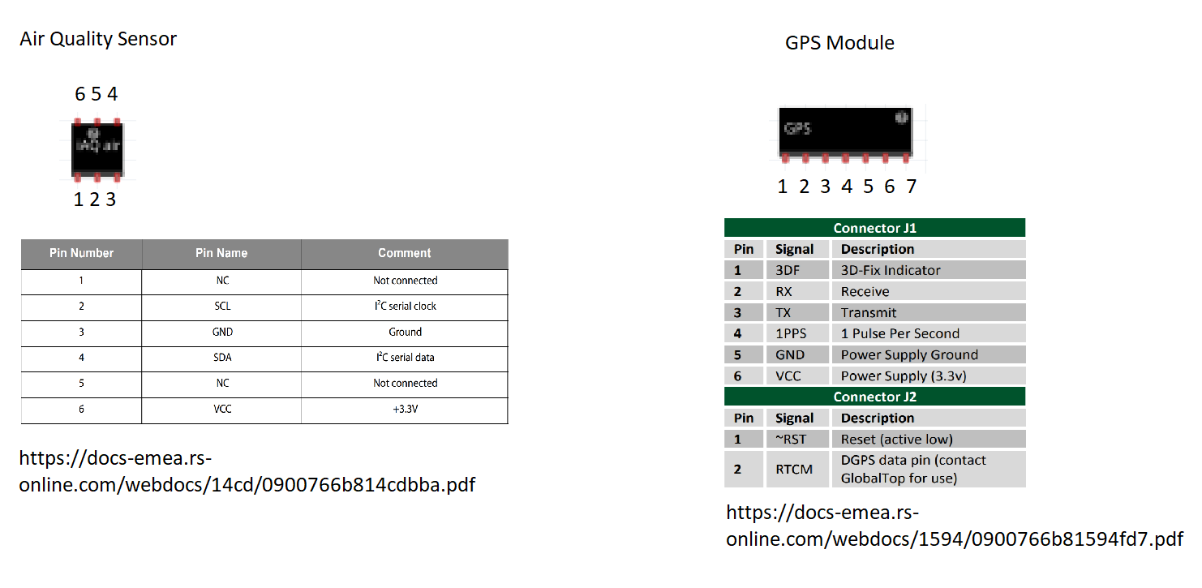

The hardware will feature three major components:

1. Raspberry Pi (RPI) (running headless rasbian with SSH enabled)
2. Air Quality Sensor (IAQ-CORE)
3. GPS Module (PmodGPS Reciever)

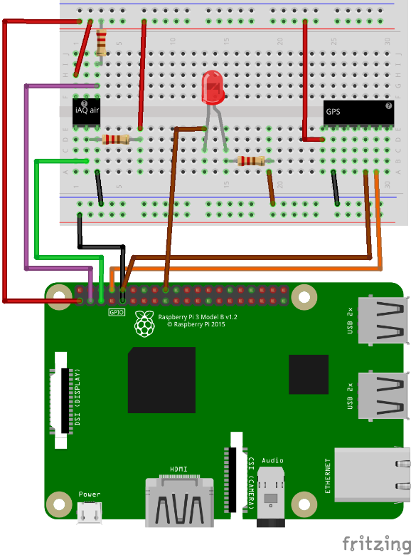

The I2C interface needs a pull up resistor on the clock and serial data pins.

Both sensors will only need to be connected to power, ground and two wires connected to the pi.

An LED should be connected to the pi as no GUI is to be used, this allows the user to know what state the RPI is currently in.

The raspberry pi will use SSH and a samba server to allow for connections on a local network and software editing.

Software

The RPI will contain two python scripts, one that will log the data on start-up of the raspberry pi, the other will upload the data once it has been collected.

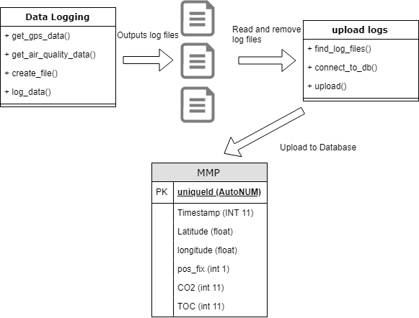

No variables have been shown to pass into each function. Most of the design of the software will be created with development. This is to give an insight of the overall functionally of the software. These methods may be separated or extended to increase functionality.

## Data_logging.py

|  |  |
| --- | --- |
| **Function** | **Description** |
| Get_gps_data() | Request serial message from GPS and return the latitude and longitude. |
| Get_air_quality_data() | Request I2C message from air quality sensor, return the CO2 prediction and the TOC value. |
| Create_file() | Create the file that will be used to log the data from the messages. |
| Log_data() | Open the file that will be used to log and log the data. |

## upload.py

|  |  |
| --- | --- |
| **Function** | **Description** |
| Find_log_files() | Find log files and read in the data collected from the data_logging script. |
| Connect_to_db() | Connect to the Aberystwyth MySQL database and upload the data from the files found in the find_log_files() method. |
| Upload() | Create SQL insert queries and commit the transactions. |